Student’s Name:
Tutor’s Name:
Course Name:
Date Submitted:

Priceline Firm Company
The Priceline Firm Company is among the largest company that helps users find rates of discount on purchases in the United States. The company was founded by Jay S. Walker. The company began as a distributor and helping is the purchases of the product such as cars and glass. This company was in its birth phase from 1999 to around 2000. During this stage, the firm tries to do a lot of innovations; a lot of transformations took place in the management (Huang, 17).
During the early2000, the business was among the largest in the United States. The company was in the growth phase strategy around those years. The company had 36 retail stores, and 90 warehouses. At the same year, the firm turns to product development to increase growth.
The firm was already in its maturing phase during that time. In spite of good earnings and remarkable growth, the raw materials had become very expensive, resulting in low profits per purchase. Similarly, competition becomes high, expenditures related to company's manufacturing, modernization increased (Huang, 17).
During the year 2000 sales tripled, and the profits after tax increased 36 times. Thus the company has remained at maturity phase strategy from the 1960s up to now. It is among the largest companies producing paint, oils, and other.

Priceline Firm Company Ansoff Matrix
markets

Market development  (Create new products for existing markets) | (Creating a new product for new markets)  diversification
(Increase sales to existing markets)  Market penetration  existing | Find new market for existing products  Product development  new
Product and services

Market development
With this strategy, a company targets a new market with its existing products. For Priceline Firm, it can expend its brands across new global markets since it is mainly in the United States.
Market penetration
Priceline Firm can use this strategy since its brands are famous in the market. To achieve this, Priceline Firm has to drive its existing brands deeper into the market.
Product development
Priceline Firm is among the top companies which command a large percentage of the market share. Since its existing businesses has reached saturation, the company can introduce new products as a way to expand the company.
Diversification
This is done when an entirely new product is introduced to the market. For this case, Priceline Firm can do this by introducing a new product to the market, but this is very risky.
In the view of the changing market in the last few decades, the best market strategy for Priceline Firm Company is market development mainly focusing the new markets. In market development, the company should emphasize on the following:
Brand position-having numerous leading brands and other private labels, brand positioning is one of the crucial factors in choosing distribution channels and market subdivisions. For instance, the Priceline Firm brand is found or old at over 2030 of its stores. On the other hand, Dutch Boy sells entirely through the merchants.
How the Priceline Firm should Distributing their products-the primary strategy to implement Priceline Firm brand positioning approach is to apply the multi-level distribution to ensure it reaches specific market segments with devoted brands. This can be done with high precision such that there is minimal crossover among various channels and seldom can conflict arise among the channels (Zott, 34}.
How do they price their products/product -Priceline Firm should not buy market share through belligerent pricing at the expense of profits. Doing so lead the company to run at loses especially as there is a lot of competition. For instance, Priceline Firm should avoid buying other depots at high prices. As an alternative, to replace the lost business, the company should pursue new supply chain contracts for both private labels on online booking (Zott, 34}.
To conclude, it takes a lot of attention in identifying the marketing strategy that would ensure the company's continued growth, specifically in a competitive and slow growing industry. In addition to that, the company gains competitive advantages.
New Venture of the Priceline Company
Jay Walker who is the founder of the Priceline Company has played a significant role in raising the $50 million that were channeled to the Upside.com. This is the website that was set with the purpose of finding the discounts that will benefit the small business travelers and provide accommodation for them.
Reason for different types of stock for Priceline Company
Despite the consistency of the Priceline Company in the market, the company has never made a move to reduce the price shares that are available in the market. This is because it has become the biggest beneficiary of the online booking since its inception,

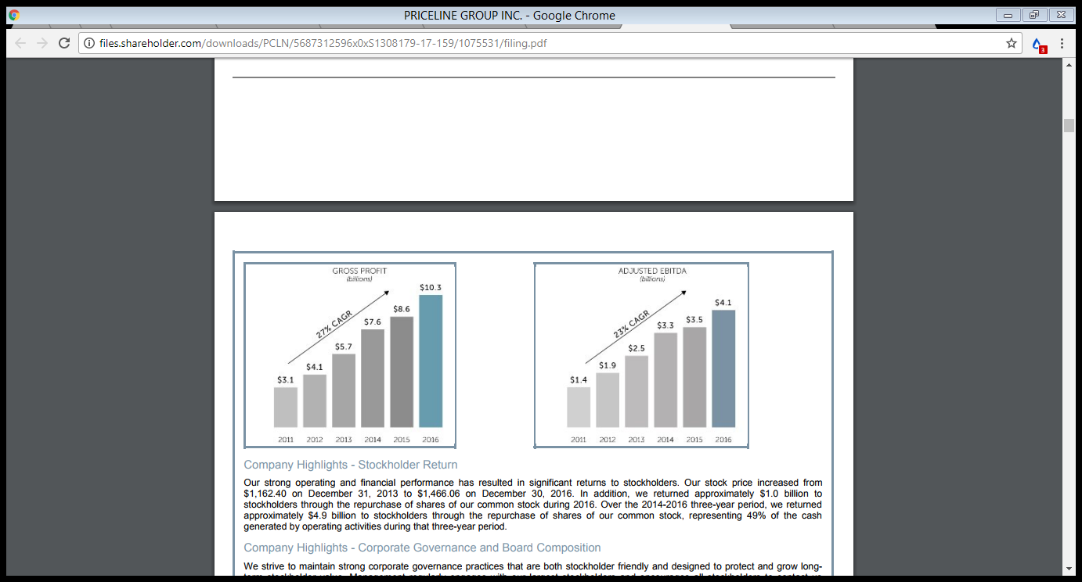

Priceline interaction move
Priceline Firm is a worldwide as a distributor operates in many states as distributor. The organization has over 254,000 workers ranging from the executives to cleaners working in its branches all over the world. The firm has ventured globally as its principal competitive tactics. This strategy makes the company vulnerable to various external environment constraints that have affected its operations. Nonetheless, the company has beaten the odds over a few years as its business appears to expand and has been opening operations in new locations.
The principal strength of this company is its robust brand image. It denotes the way Priceline Firm presents itself to its consumers. Its brand image perfectly signifies the quality of services the firm offers and that consistently increases consumer's loyalty. Additionally, its brand is useful in creating a strong emotional connection between its customers and its services as well as the online booking services itself. This makes both employees and consumers motivated and proud being associated with the company. This creates a competitive brand loyalty as well as well as a competitive advantage. The second company’s strength is its value-based appraising approach which helps it maximize income. Principally, the degree in which Priceline Firm formulates its prices helps define the highest amount a consumer can pay without dispelling them. Priceline Firm pricing strategy leads to increased sales and profits and identifies the best approaches.
On the other hand, the company has numerous weaknesses which if not looked into can lead to loses reduced company's growth. Its major weaknesses are outdated technology as well as improper expansion approaches. This is because technology plays a crucial role given that the company has branches globally. Since the firm deals with beverages, its areas of operations should be improved, for instance, the company should launch an online platform where consumers can place their orders. The company can copy this from other firms as most of them have succeeded. Even if Priceline Firm targets to improve its presence in almost all parts of the world, its expansion strategies are not up to date. The appropriate strategic design is central to a company's creation of precise development plans (Anderson 24}.
While Priceline Firm is faced with various challenges, the company has numerous opportunities that if utilized well can lead to positive results. Growth is the biggest and extensive opportunity that Priceline Firm can exploit. This company may be boasting of having numerous booking outlets in the United States, but it is about to launch other branches in numerous locations around the world. One necessity for Priceline to expand is the need to eliminate self-cannibalism. This is an exercise in which a company cuts its prices or launching of brand products and services in the same market which already has established outlets. Growth can be attained by exploiting technological factors, for instance, the mobile e-commerce. The other opportunity for this company are the economic factors for instance increase in national income, creating of trading opportunities, as well as a reduction in unemployment levels. Despite all these opportunities, there are threats or risks which the company faces. The major threat which Priceline Firm faces is the risk of substitutes. The other industries that acts in their line of duty, has a high competition in the market. Tight competition comes from numerous substitute products or services in the market.
For Priceline Firm to improve, it should put more emphasis on its weaknesses and threats. First and foremost, the company has a massive following on social media. Consequently, it should maximize this and market itself more. This can involve creating an online platform where customers can view and place their orders. Secondly, Priceline Firm should personalize its products, and it would gain more customers and retain the existing ones. Additionally, Priceline Firm should also eliminate partners who care less about bad attitude, irrespective of their superiority. These are among the things which turn away customers. Finally, it should reduce its rate of opening new stores as this inhibit the brand quality.
To conclude, it is clear that Priceline Firm Corporation has expanded its operations to almost every continent within a short time. This growth, as well as the expansion, observed currently is attributed to intense management practices that have yielded fruits. Additionally, the company's quality products contribute significantly to the success of this business. This has helped to attract consumers and also maintain their loyalty. On the other hand, Priceline Firm faces numerous challenges which are common to any other organization, but for the company to offer a stiff competition and maintain the lead, it should improve on its weaknesses as well as threats.

Work cited
Anderson, Chris K. "Setting prices on priceline." Interfaces39.4 (2009): 307-315.
Zott, Christoph, and Raphael Amit. "The fit between product market strategy and business model: implications for firm performance." Strategic management journal 29.1 (2008): 1-26.
Huang, Xiao, Greys Sošić, and Gregory Kersten. "Selling through Priceline? On the impact of name-your-own-price in competitive market." IISE Transactions 49.3 (2017): 304-319.

